cd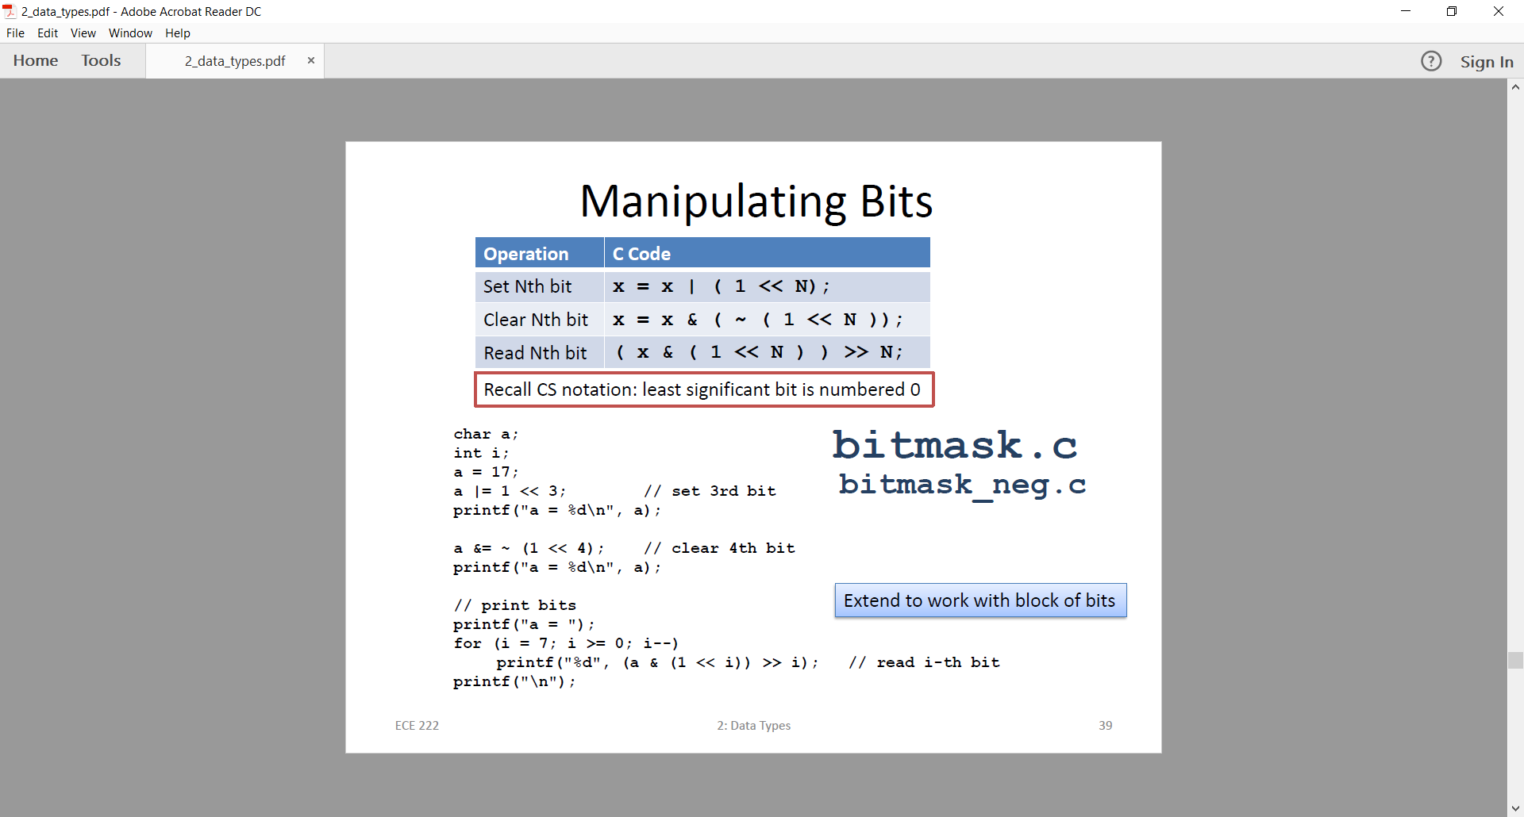

Convert mask to Decimal or Hex

Use bitmask.c program

Use print

Gdb p /t – prints binary, type the variable afterwords

Gdb /x – hex

Break at function names

Use intermediate variables

No arrays

Also use LCD.c * reset PortOut = 0x85 after print_bits in the for loop

